|  |  |  |  |  |  |  |  |  |  |  |  |  |  |  |
| --- | --- | --- | --- | --- | --- | --- | --- | --- | --- | --- | --- | --- | --- | --- |
| **Monday** | | | **Tuesday** | | | **Wednesday** | | | **Thursday** | | | **Friday** | | |
| Totals include entrée, sides, dessert, fruit, bread, milk & margarine. *Higher sodium item (>500 mg), Shading = High sodium meal (>1200 mg).    Cal = Total Calories,  Pro = Total Protein,  Na = Total Sodium  (also in parentheses) | | | **1** Breaded  Fish (300)  Corn (5)  Br. Sprouts (15)  Bun (250)  Chilled Fruit (10) | | | **2** Beef**,** Peppers & Onions (305)  Black Beans (140)  Rice (270)  Tortilla (170)  Rice Pudding (40) | | | **3** Chicken (605) Cordon Bleu*  Swt Potato (55)  Berry Crisp (105)  Caesar Salad(290)  Oat Bread (150) | | | **4**  **Holiday No Meal** | | |
| Cal  720 | Na  780 | Pro  35 | Cal  785 | Na  1060 | Pro  40 | Cal  970 | Na  1335 | Pro  35 |
|  | | |
| **7** Smothered Pork w/Mushrooms(290)  Sweet Potato (25)  Cauliflower (15)  WW Roll (240)  Cookie (60) | | | **8** Pasta & Meatballs(410)  Veg Blend (15)  Oat Bread (150)  Pineapple (5) | | | **9 Special:** Chicken Salad (170)  Egg Salad (175)  Orzo Salad (315)  Coleslaw (15)  Berry Parfait (5)  Finger Rolls (240) | | | **10** Pot Roast(195)  Beets (140)  Butternut (15)  Biscuit (280)  Fresh Fruit (5) | | | **11** Cheese Omelet (310)  Tk Sausage(280)  Rstd Potato (5)  Ratatouille (115)  Fruit Loaf (170)  Applesauce (15) | | |
| Cal  880 | Na  760 | Pro  45 | Cal  785 | Na  820 | Pro  30 | Cal  1115 | Na  1285 | Pro  35 | Cal  595 | Na  765 | Pro  40 | Cal  860 | Na  1025 | Pro  35 |
| **14** Ground Beef & Cabbage (305)  Rsted Potatoes & Red Peppers (5)  Rye Bread (220)  Chilled Fruit (10) | | | **15** Garlic & Lemon Fish (60)  Corn (5)  Cr. Spinach (215)  MG Bread (150)  Gelatin (15) | | | **16 Cold:** Tortellini Salad w/Peas (310)  Cucumber & Tomato Salad (220)  Cookie (230)  Oat Bread (150) | | | **17** *Marry Me Chicken*(740)*  Couscous (5)  Green Beans (5)  Roll (260)  Orange (5) | | | **18** Turkey  Chili*(705)  Brown Rice (25)  Cornbread (180)  Mandarins (5) | | |
| Cal  650 | Na  680 | Pro  35 | Cal  635 | Na  565 | Pro  35 | Cal  1020 | Na  1040 | Pro  35 | Cal  960 | Na  1140 | Pro  35 | Cal  870 | Na  1040 | Pro  35 |
| **21** *Hawaiian Chicken (335)*  Rice (5)  Veg Bend (25)  Chilled Fruit (5)  WW Roll (240) | | | **22** Meatloaf w/Gravy (340)  Mshd Potato (110)  Peas (60)  MG Bread (150)  Fresh Fruit (5) | | | **23 Cold:** Seafood Salad (480)  Garden Salad (35)  Tabouli (80)  Yogurt(75)/Juice(0)  Vienna Bread (360) | | | **24 B-day:** BBQ Pulled Pork*(510)  Swt Potato (55)  Collard Greens (35)  Bun (250)  Cake (175) | | | **25** Macaroni & Cheese* (815)  Stewed  Tomatoes (30)  Oat Bread (150)  Chilled Fruit(10) | | |
| Cal  660 | Na  740 | Pro  40 | Cal  740 | Na  790 | Pro  40 | Cal  540 | Na  1025 | Pro  20 | Cal  755 | Na  1150 | Pro  40 | Cal  685 | Na  1130 | Pro  25 |
| **28** Turkey w/Gravy* (765)  Mshd Potato (110)  Carrots (65)  LS WW Bread (0)  Chilled Fruit (10) | | | **29** Lasagna w/Marinara*(550)  Veg Blend (25)  Garlic Roll (240)  Cookie (60) | | | **30** Hot Dog* (540)  Baked Beans (370)  Warm Apples (10)  Coleslaw (15)  Roll (250) | | | **31 Cold:** Rst Beef & Cheese (200)  Chips (170)  Garden Salad (35)  MG Bread (300)  Fresh Fruit (5) | | | A $2.00 confidential donation is suggested per meal. Donation letters mailed monthly.  Nutrition Questions? Leigh @ 978- 651-3023 [lhartwell@agespan.org](mailto:lhartwell@agespan.org) | | |
| Cal  525 | Na  1080 | Pro  35 | Cal  645 | Na  1090 | Pro  30 | Cal  830 | Na  1485 | Pro  30 | Cal  620 | Na  890 | Pro  35 |

To Cancel Meals Please Call **978-686-1422** at least 24 Hours Before Service

 = Alternate for fish available - Menus Subject to Change Without Notice

Brought to you by the Older Americans Act – Italics = Meal Description on back of menu

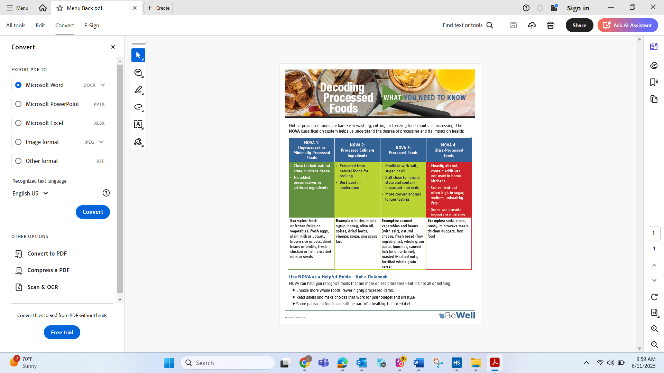

**Meal Descriptions**

***Marry Me Chicken:*** Chicken with a creamy tomato sauce & Italian herbs.

***Hawaiian Chicken:*** Chicken with a pineapple sauce, peppers & onions.