Monday |  |  | Tuesday |  |  | Wednesday |  |  | Thursday |  |  | Friday
Totals include entrée, sides, dessert, fruit, bread, milk & margarine.  *Higher sodium item (>500 mg), Shading = High sodium meal (>1200 mg).  Cal = Total Calories, Pro = Total Protein, Na = Total Sodium (also in parentheses)  - = Substitute available for Fish  Brought to you by the Older Americans Act  A $2.00 confidential donation is suggested per meal. Donation letters mailed monthly.  Menu Subject to Change Without Notice  Nutrition Questions? Contact Leigh @ 978-651-3023 or lhartwell@agespan.org  Bolded items: description on menu back |  |  |  |  |  |  |  |  |  |  |  | 1 Chicken  Piccata (430)  Rice Pilaf (40)  Broccoli (10)  WW Bread (165)  Pudding (190)
 |  |  |  |  |  |  |  |  |  |  |  | Cal  650 | Na  960 | Pro  40
4 Hamburger (415)  Sweet Potato (55)  Beets (140)  WW Roll (250)  Gelatin (15) |  |  | 5 Breaded  Fish (330)  Mixed Veg (5)  Mshd Potato(110)  Roll (260)  Cookie (60) |  |  | 6 Chicken Teriyaki* (735)  Green Beans (5)  Veggie Rice (85)  MG Bread (150)  Pineapple (5) |  |  | 7 Cold; Turkey & Cheese Chef Salad*(520)  Bean Salad (230)  Fresh Fruit (5)  Pita Bread (160) |  |  | 8 Eggplant Parmesan*(1050)  Pasta (5)  Veg Blend (15)  LS WW Brd (0)  Mandarins (10)
Cal  675 | Na  1095 | Pro  30 | Cal  675 | Na  890 | Pro  25 | Cal  615 | Na  1005 | Pro  40 | Cal  460 | Na  910 | Pro  30 | Cal  715 | Na  1200 | Pro  30
11 Greek Chicken*(520)  Risotto (105)  MG Bread (150)  Chilled Fruit (5) |  |  | 12 American Chop Suey (350)  Broccoli (10)  WW Garlic  Roll (240)  Fresh Fruit (5) |  |  | 13 Cold: Tuna Salad (240)  3 Bean Salad(325)  Garden Salad (35)  WW Bread (330)  Pineapple (5) |  |  | 14 Special: BBQ Pork* (510)  Peach Cobbler (40)  Green Beans (5)  Potato Salad(100)  Roll (250) |  |  | 15 Broc & Cheese Egg Bake (340)  Potatoes (25)  Carrots (65)  Fruit Loaf (170)  Yogurt(75)Juice(0)
Cal  655 | Na  915 | Pro  40 | Cal  730 | Na  735 | Pro  40 | Cal  570 | Na  1060 | Pro  35 | Cal  955 | Na  1030 | Pro  40 | Cal  815 | Na  765 | Pro  25
18 Smothered Pork w/Mushrooms(290)  Sweet Potatoes(30)  Cauliflower (15)  WW Roll (240)  Applesauce (20) |  |  | 19 Pasta & Meatballs (395)  Veg Blend (15)  Oat Bread (150)  Mandarins (10) |  |  | 20 Omelet (310)  Tky Sausage(280)  Rstd Potatoes (5)  Ratatouille (115)  Bread (180)  Fruit Whip (5) |  |  | 21 Cold: Chicken Salad (395)  Quinoa Salad (135)  Carrot Slaw (70)  MG Bread (300)  Cookie (60) |  |  | 22 Pot Roast*(565)  Beets (140)  Butternut (15)  Biscuit (280)  Fresh Fruit (5)
Cal  850 | Na  725 | Pro  45 | Cal  660 | Na  805 | Pro  35 | Cal  805 | Na  1025 | Pro  35 | Cal  930 | Na  1090 | Pro  45 | Cal  600 | Na  1130 | Pro  35
25 Thai Beef & Peppers (230)  Broccoli (10)  Brown Rice (25)  WW Bread (165)  Chilled Fruit (5) |  |  | 26 Hot Dog*(540)  Baked Beans(370)  Warm Apples(10)  Coleslaw (15)  Roll (250) |  |  | 27 Cold:  Tortellini Salad w/Peas (310)  Cucumber & Tomato Salad (220)  Fruit (5)  Oat Bread (150) |  |  | 28 Birthday Marry Me Chicken*(740)  Couscous (5)  Green Beans (5)  Cupcake (175)  Roll (260) |  |  | 29 Lemon Garlic Fish (60)  Corn (5)  Spinach (210)  MG Bread (150)  Gelatin (15)
Cal  700 | Na  570 | Pro  35 | Cal  830 | Na  1455 | Pro  30 | Cal  775 | Na  810 | Pro  30 | Cal  975 | Na  1310 | Pro  110 | Cal  635 | Na  565 | Pro  35
To Cancel Meals Please Call 978-686-1422 at Least 24 Hours Prior to Service
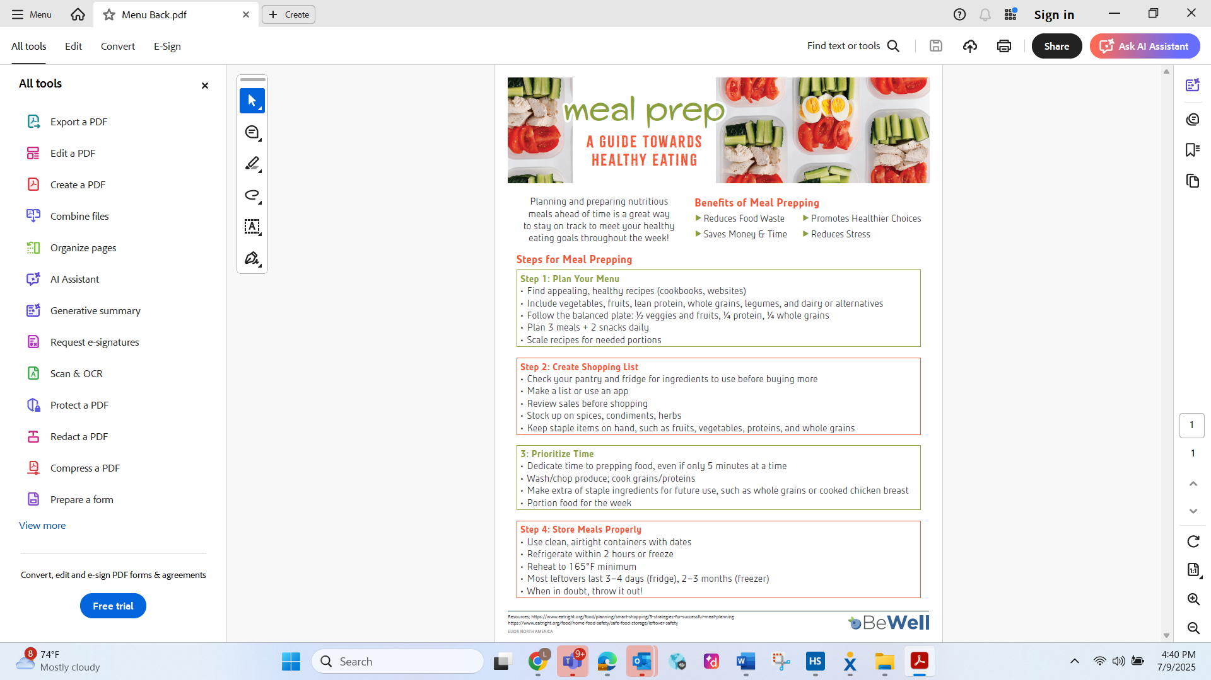
Meal Descriptions
Greek Chicken: Chicken, Spinach, Peppers, Feta Cheese & Olives
Thai Beef & Peppers: Ground Beef, Soy Sauce, Basil, Oyster Sauce, Garlic & Onions

