Monday |  |  | Tuesday |  |  | Wednesday |  |  | Thursday |  |  | Friday
1  Labor Day No Meals Served |  |  | 2 Meatloaf w/Gravy (340)  Mshd Potato (110)  Peas (60)  MG Bread (150)  Fresh Fruit (5) |  |  | 3 Cold:  Egg Salad (170)  Garden Salad (35)  Tabouli (70)  Yogurt(75)/Juice(0)  Vienna Bread (360) |  |  | 4 BBQ Pulled Pork*(510)  Swt Potato (55)  Collard Greens (35)  Bun (250)  Applesauce (20) |  |  | 5 Crab Cake*(510)  Rice&Beans (85)  Peach Crisp (20)  Oat Bread (150)  Cuke Salad (40)
 |  |  | Cal  740 | Na  790 | Pro  40 | Cal  615 | Na  715 | Pro  25 | Cal  710 | Na  995 | Pro  40 | Cal  745 | Na  1065 | Pro  25
8 Turkey  w/Gravy* (765)  Mshd Potato (110)  Carrots (65)  LS WW Bread (0)  Chilled Fruit (5) |  |  | 9 Lasagna w/Marinara*(550)  Veg Blend (25)  Garlic Roll (240)  Cookie (60) |  |  | 10 Hot Dog* (540)  Baked Beans (370)  Warm Apples (10)  Coleslaw (15)  Roll (250) |  |  | 11 Cold: Rst Beef & Cheese (200)  Chips (170)  Salad (35)  MG Bread (300)  Fresh Fruit (5) |  |  | 12  No Meals  Staff Appreciation Day
Cal  525 | Na  1080 | Pro  35 | Cal  645 | Na  1090 | Pro  30 | Cal  830 | Na  1455 | Pro  30 | Cal  620 | Na  890 | Pro  35
15 Burger (425)  Sweet Potato (55)  Beets (140)  WW Roll (250)  Gelatin (15) |  |  | 16 Breaded  Fish (330)  Mixed Veg (5)  Mshd Potato (110)  WW Bread (165)  Chilled Fruit (5) |  |  | 17 Special: Pineapple Chicken  & Peppers (350)  Fried Rice (65)  Berries&Rhubarb (5)  Garden Salad (175)  WW Roll (240) |  |  | 18 Cold Turkey & Cheese Chef Salad*(520)  Bean Salad (335)  Fresh Fruit (5)  Pita Bread (160) |  |  | 19 Eggplant Parm *(1050)  Pasta (5)  Veg Blend (15)  LS WW Brd (0)  Mandarins (10)
Cal  675 | Na  1095 | Pro  30 | Cal  715 | Na  870 | Pro  25 | Cal  770 | Na  960 | Pro  40 | Cal  660 | Na  1145 | Pro  40 | Cal  715 | Na  1200 | Pro  30
22 Greek Chicken*(520)  Risotto (105)  MG Bread (150)  Chilled Fruit (5) |  |  | 23 Broc & Cheese Egg Bake (340)  Potatoes (25)  Carrots (65)  Fruit Loaf (170)  Yogurt (75)  Juice (0) |  |  | 24 Cold: Tuna  Salad (240)  3 Bean Salad (325)  Garden Salad (35)  WW Bread (330)  Chilled Fruit (5) |  |  | 25 Bday: American Chop Suey (440)  Broccoli (10)  WW Garlic  Roll (240) Cupcake (175) |  |  | 26 Sausage Peppers & Onions*(630)  Tater Tots (335)  Butternut (20)  Roll (270)  Fresh Fruit (5)
Cal  655 | Na  915 | Pro  40 | Cal  815 | Na  765 | Pro  25 | Cal  570 | Na  1060 | Pro  35 | Cal  830 | Na  1000 | Pro  45 | Cal  795 | Na  1385 | Pro  30
29 Smothered Pork w/Mushrooms(290)  Sweet Potato (30)  Cauliflower (15)  WW Roll (240)  Applesauce (20) |  |  | 30 Pasta & Meatballs (395)  Veg Blend (15)  Oat Bread (150)  Mandarins (10) |  |  | Totals include entrée, sides, dessert, fruit, bread, milk & margarine.  *Higher sodium item (>500 mg), Shading = High sodium meal (>1200 mg).Cal = Total Calories, Pro = Total Protein, Na = Total Sodium (also in parentheses) A $2.00 confidential donation is suggested per meal. Donation letters mailed monthly.  Nutrition Questions? Leigh @ 978- 651-3023 lhartwell@agespan.org  = Alternate for fish available  Menus Subject to Change Without Notice
Cal  845 | Na  725 | Pro  45 | Cal  660 | Na  805 | Pro  35
To Cancel Meals Please Call 978-686-1422 at least 24 Hours Before Service
Brought to you by the Older Americans Act – Italics = Meal Description on back of menu
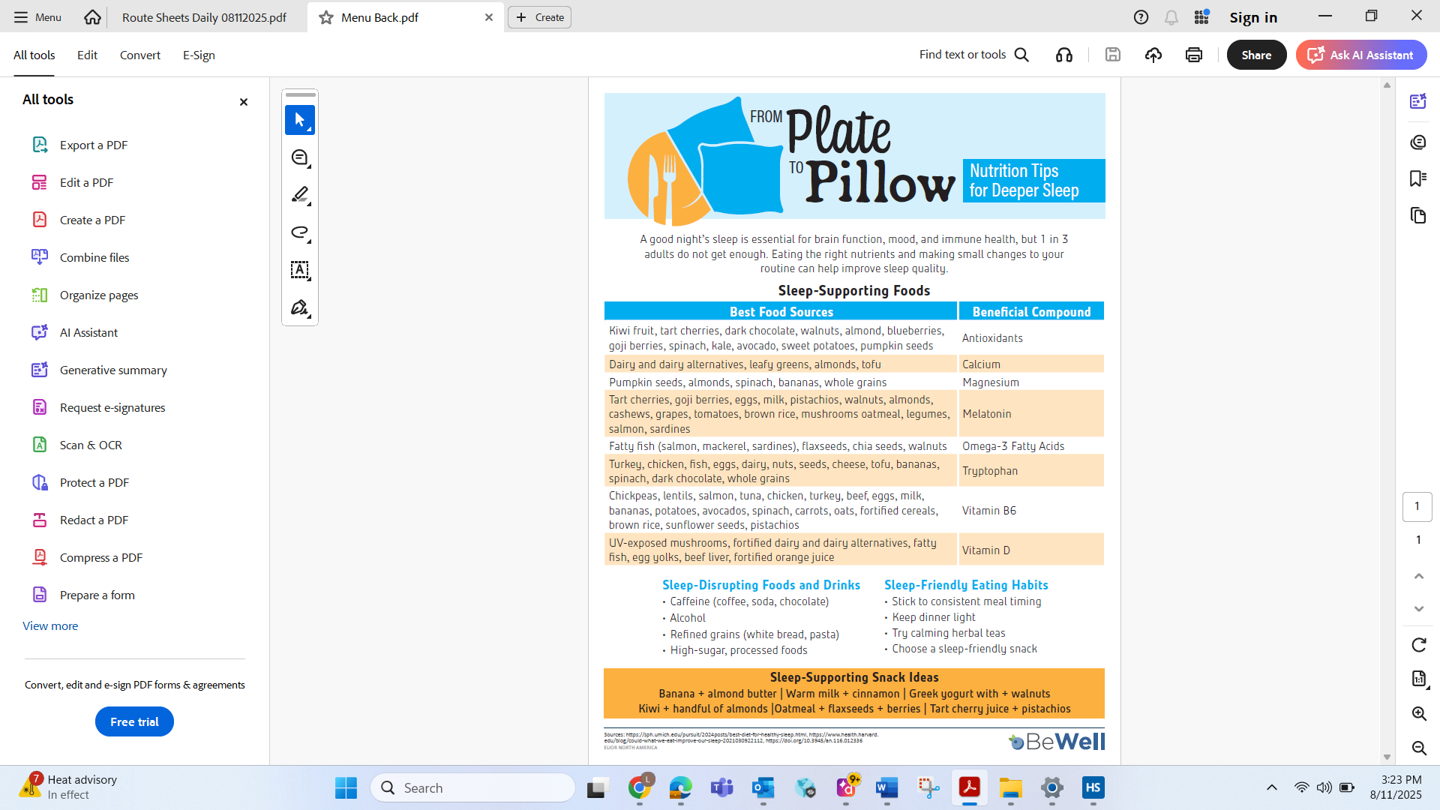
Greek Chicken = Chicken with Spinach, Feta, peppers & olives

