Monday | Tuesday | Wednesday | Thursday | Friday
Nutrition Questions? Contact Leigh Hartwell 978-651-3023 or lhartwell@agespan.org  A $2 donation per meal is suggested. Donation letters are mailed monthly. |  | 1 Sloppy Joe  Warm Berries  Corn  Garden Salad  Burger Bun | 2 Potato Crunch Fish  Rice Pilaf  Brussels Sprouts  WW Sandwich Roll  Apple Slices | 3 Pork, Rice & Beans  Peas & Carrots  Oat Bread  Fresh Orange
6 Apricot Meatballs  Couscous  Beets  Vienna bread  Pineapple | 7 Beef & Peppers Pasta  Zucchini &  Summer Squash  WW Bread  Mandarins | 8 Cold: Turkey  Spinach Salad  Tabouli  MG Bread  Juice  Gelatin | 9 Grilled Chicken  Corn  Honey Glazed Carrots  Oat Bread  Fresh Fruit Salad | 10 Beef Stew  Rice  WW Dinner Roll  Fresh Fruit
13 Beef Fajita  Black Beans  Spanish Rice  Tortilla  Lorna Doones | 14 Turkey w/Gravy  Beets  Carrots  LS Wheat Bread  Applesauce | 15 Breaded Chicken  w/Marinara  Pasta  Zucchini  WW Bread  Fresh Orange | 16 BBQ Pulled Pork  Sweet Potato Tots  Corn  Burger Bun  Mandarins | 17 Lentil Stew  Brussels Sprouts  WW Dinner Roll  Juice  Gelatin
20 Chicken Stir Fry  Mandarin Veg Blend  Brown Rice  Vienna bread  Pineapple | 21  Volunteer Appreciation Day  No Meals Served | 22 Hot Dog  Baked Beans  Cinnamon Apples  Slaw  Roll | 23 Cold: Turkey  Italian Pasta Salad  Garden Salad  Oat Bread  Grahams | 24 Beef Burgundy  Egg Noodles  Broccoli  MG Bread  Gelatin
27  NO Meals  Memorial Day | 28 Pasta  Turkey Marinara  Broccoli  Dinner Roll  Applesauce | 29 Lemon &  Garlic Chicken  Rice Pilaf  Beets  MG bread  Pineapple | 30 Hamburger w/Gravy  Orzo  Peas  Oat Bread  Chilled Fruit | 31 Breaded Fish  Roasted Potatoes  Ratatouille  MG Bread  Fresh Fruit
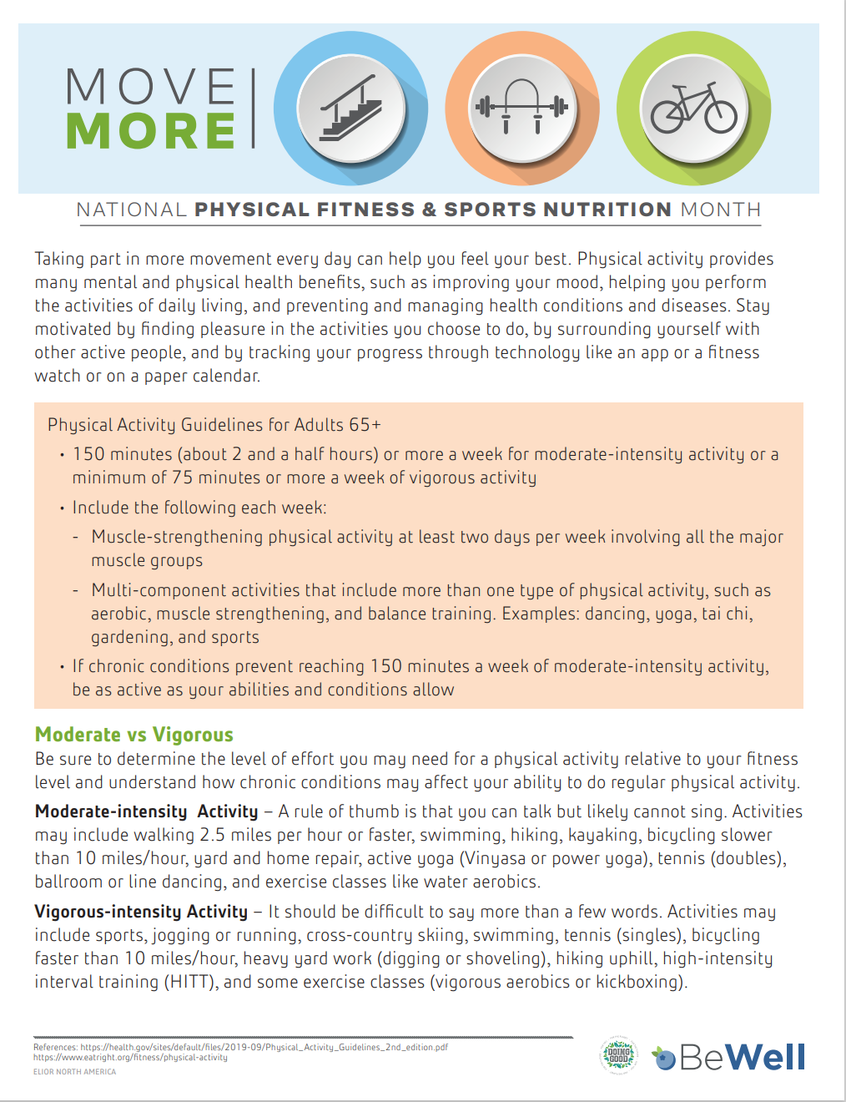
To Cancel Meals: Please call 978-686-1422 at least 24 hours prior to service. Menu subject to change without notice.

